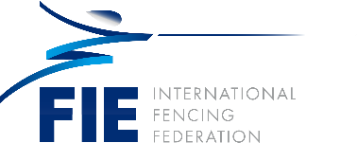

**Oleg Peskov (KAZ)**

Oleg Peskov born August 13, 1959, in Alma-Ata, Kazakhstan. He has had numerous achievements:

* A member of the national epee team of Kazakhstan
* Junior champion of Kazakhstan in 1976
* President of the Fencing Federation of the Republic of Kazakhstan from 2004 to 2012
* Honorary Personality of Sport of the Republic of Kazakhstan
* Member of the FIE Disciplinary Commission from 2008 to 2012
* Member of the FIE Executive Committee from 2012 to the present

**Education**

* 1977 – 1983 Almaty Architecture and Construction Institute Construction engineer (industrial engineering and civil construction)
* 2016 – 2018 Diplomatic Academy of the Ministry of Foreign Affairs of the Russian Federation (World Economy Master in World Economics)

**Professional**

* 1976 to 1986: Worked in construction companies of Kazakhstan
* 1986 to Present: worked in the Government and Presidential Administration of the Republic of Kazakhstan
* 2013 to Present: Diplomatic service as the Minister-Counsellor of the Embassy of the Republic of Kazakhstan in the Russian Federation
* 2019 to Present: Advisor for Trade Representation of the Republic of Kazakhstan in the Russian Federation
* Recipient of the state award of the Republic of Kazakhstan.

Married with two daughters.